**[The Path to the Dark Side is Covered in PB&J](http://www.100wordstory.org/the-path-to-the-dark-side-is-covered-in-pbj/)**

Sarah’s eight-year-old son is freaking out. His one perfect origami Yoda is missing. Dozens of them scattered everywhere after weeks of social distancing, hours of folding instead of schooling. She wishes she kept her cool when her “dieting” husband ate a year’s supply of peanut butter in seven weeks. Wishes she hadn’t rage-cleaned. “I’ll try my best,” she says. “There is no try!” her son wails. She gloves up and digs in, pulling out half-eaten peanut butter sandwiches, unopened packets of artificial sweetener, rancid red onions, and so many wasted paper towels. At the bottom, no Yoda. Only more rage.

[**Photo Story: Wait**](http://www.100wordstory.org/photo-story-wait/)

Wait your turn, signs proclaim. Wait for Chinese food. Wait to pick up cocktails from the bar, your only Friday night friends now. Wait your turn to see your older sister, Nancy. Nancy with dark jokes about suicides, who tells you she loves you by calling you Mister Adorkable through Zoom-filled screens. Nancy, who knows every line of the Big Lebowski and fights life with grace. They don’t teach you logic. Why draw the line here and not there? Why not cross? You hesitate. Imagine Nancy contaminated. Imagine her gasping, energy drained. What are the odds, frankly? What if? Wait.

[**Lipstick**](http://www.100wordstory.org/lipstick/)

We learned to paint our mouths kissable, but were taught not to. By the parish priest, by our mothers, by *Seventeen* magazine. Never on the first date, never more than one boy at a time, never below the neck. We practiced on the mirror and at slumber parties. When boys scratched on the window, we giggled and shivered. Only Lana slipped out, came back smeared and tight-lipped, full up with stories she wouldn’t tell us. At school on Monday, we lipsticked the mirror in the third-floor girl’s room: LANA SUCKS. Later we all learned. Later we all did it.

[**Photo Story: Breaths Caught on His Echoes**](http://www.100wordstory.org/photo-story-breaths-caught-on-his-echoes/)

When he burned, she watched from the window as the casket shifted toward the chamber, as the cardboard lid vibrated, shuddered apart at the seam to reveal his hands, a moment before they would blossom in the fire that reflected in the metal frame of the door—the bloom that would arc in delicate peels, gray crepe flakes folding back like flower bulb sheaths, collapsing in stirs of ashes.

At night, when she needed, when her breaths caught on his echoes, blue note flecks from his voice, he palmed from the bottoms, from the swallows, to lull her stranded heart.

[**Lost Boys**](http://www.100wordstory.org/lost-boys/)

Years later, we would have mortgages, car payments, and life insurance, but no recollection of when we all dropped acid together in the high desert after graduation. How when the sun started to come up, the clouds looked like crusader kings lined up against a limoncello sky, lances shooting past the horizon. How someone snapped a polaroid directly into the light to capture us saying we were gonna remember this forever. This is it, we all agreed, our pupils swallowing what remained of our iris meat, the polaroid turning pitch black. This is the moment right before it all happens.

[**Domestic**](http://www.100wordstory.org/domestic/)

Luke started to howl as Mum click-clicked the washing machine. “He’ll be all nice and fresh!” she cried in her bright and ruthless voice. Like when she’d kidnapped my cloth rabbit stuffed with her old stockings. Churned in boiling water and spun around, rabbit was so terrified he wet himself. Things went into her laundry basket as themselves and came out flattened.

Pushing aside the baby bouncer, I shouted, “You’re cruel and nasty. And a bad mother.”

My head was about to fly off and land on a shelf, still shouting bad mother, when she let go of my shoulders.

[**Embroidery**](http://www.100wordstory.org/embroidery/)

Because I couldn’t find you, I embroidered little houses and visited each one. Some houses floated, tugging on their threads. Others were sewn to their foundations. I opened woven doors, tred on woven floors, until I found you in our old house, playing the piano. We played a duet and made love in the woven bedroom. Each skein was an adventure. Threads the color of flowers. But when we remembered tearing each other’s coats in a city park, we ripped up the house. Thread still clings to my breasts and arms. I play both parts of the duet at once.

[**Photo Story: The Spoon**](http://www.100wordstory.org/photo-story-the-spoon/)

The fork snored lightly, sound asleep and unaware of what tomorrow would bring. He lay beside her, on his back, wide awake. Moonlight spilled across the room. In the quiet, he could hear everything. The neighbor’s cat and a faint melody that might have been a violin. A dog’s chortle. A cow’s moo. The clock’s tick. It was almost time to go. He was too tense to relax; too excited to sleep. One more hour. Then he would slip out of bed, grab his duffel, and go pick up Dixie.

He smiled, “What a dish!”

Tonight they were running away.

[**Shrinking**](http://www.100wordstory.org/shrinking/)

Nia didn’t mind at first. Being at her kids’ eye-level made life easier. Their odd stories and complaints became miraculously comprehensible. Playing dress-up with them was more fun too. She liked staggering around in her too-big red pumps and Issey Miyake suits, flapping the jacket’s long, empty arms until they fizzed with laughter. But shrinking became less amusing as the kids grew bigger, and she smaller. Some days, she had to stamp her tiny feet on their dinner plates to get noticed. Some days, she had to check her reflection in a teaspoon to make sure she was still there.

[**Uncle John Isn’t Really My Uncle**](http://www.100wordstory.org/uncle-john-isnt-really-my-uncle/)

He’s just a man who works at the candy company. When he visits, he brings me and Mom bags of malformed candies, the ones that weren’t good enough to package. Chocolates with chunks missing. Gummy bears sliced in half. Every night he calls his wife and daughter. “Shhh,” he says to us. “I love you, goodnight,” he whispers into the phone. After dinner, Mom and Uncle John dance in the backyard. I watch from my window. Mom puts her head on Uncle John’s shoulder. I run my tongue over my teeth, feeling for the last sweet bits still stuck inside.

[**Fading**](http://www.100wordstory.org/fading/)

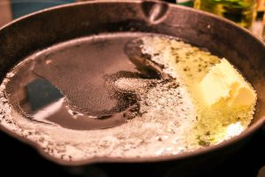

My parents are fading. As did theirs. My father’s unyielding certitude has been momentarily displaced by bewilderment, betraying a loss of relevance in a new world order. Their eyes brim as they look at me through the glass of the train carriage. As do mine. I took the same train forty years ago to be free of a world that restrained, that suffocated. I open the door and alight, to touch their feet out of respect. I silently promise to return more frequently. Though home is now six thousand miles away. Old grievances have become butter in a hot pan.

[Honey](http://www.100wordstory.org/honey/)

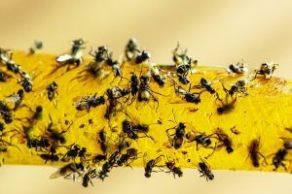There are bees trapped into the walls of an abandoned home. There are ghosts trapped in the attic, swaying to their hum. There are flies trapped on a glue strip, beating their wings in anger. There’s a girl in the kitchen, trying to release them. She pulls the flies’ transparent wings—they come off in her fingers. She kicks open the attic door—the ghosts fade to the corners. She takes a hammer to the drywall—bees thicken the air, swirling towards the attic, sticking in the glue. The girl reaches through wall, touches her fingers to her lips.

# [A Tiger on the Rue du Bac](http://www.100wordstory.org/a-tiger-on-the-rue-du-bac/)

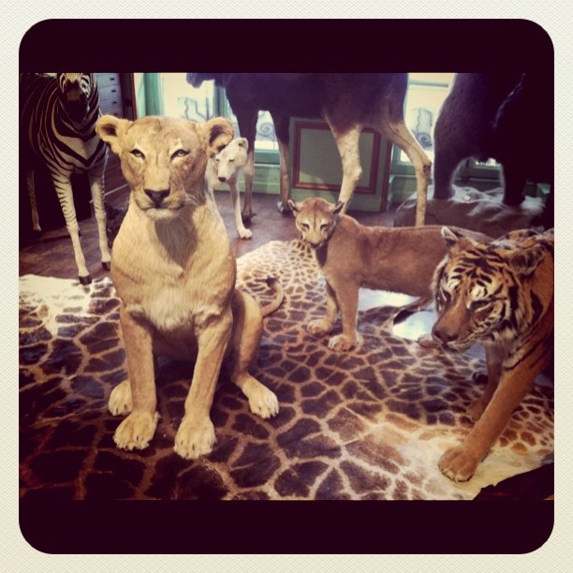Savannah sneaks out of the hotel while her dad and Veronica rest up for more museums of naked cherubs and armless statues. They’re always dragging her to awful places and oohing and aahing at each other like she doesn’t exist.

Not today.

Heart bumping, she inhales croissant-smell and ventures past the shops to hunt a hideout, almost running back at the policeman’s stare. Then she sees the lion.

Fanged. Real.

“Taxidermie,” the sign says.

Veronica hates cats.

Inside, up a spiral staircase, swans.

Alligators.

Shimmering blue butterflies.

A dagger-clawed tiger.

Savannah creeps beneath his perfect belly and whispers a hiss.

# [All White Male Authors Look Alike](http://www.100wordstory.org/all-white-male-authors-look-alike/)

She bought him a book by John Barth as a birthday gift.

“You like him, don’t you?” she asked.

He didn’t know how to tell her that it was Donald Barthelme whom he enjoyed. Barth. Barthelme. Yeah, they sounded similar. But then there were Frederick, Steven, and Donald Barthelme, each with his own unique style, not unlike Barth, but it was Donald’s minimalist absurdism that he loved most.

He looked at the cover (Tidewater having since evolved into Hampton Roads, with hopes of becoming “The 757”) and nodded. After all, he had nothing against Barth.

“It’s perfect,” he responded, smiling.

[Child Play](http://www.100wordstory.org/child-play/)

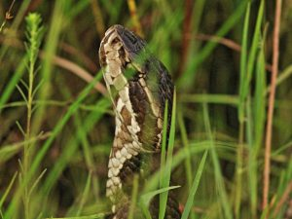His daughters ran from the back of the yard screaming “Snake! Snake!” The poisonous water moccasin slithered after his children, but his wife was the first to react. She grabbed the shovel and chopped off the snake’s head. His daughters danced in delight as the headless body writhed in the thick summer grass.

His daughters peeled the dead serpent with Swiss Army knives. Their little hands struggled, but they stripped the snake in violent, choppy scraps, ripping scales from muscle. He wanted to stop them, but his wife cheered them on, sipping her wine, the red blend staining her teeth.

# [Photo Story: School Fair](http://www.100wordstory.org/photo-story-school-fair/)

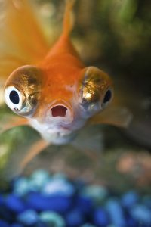Nina’s four, I’m seven. At the penny-toss Nina wins a goldfish with silvery fins—everyone cheers. I toss all my pennies, win nothing. When it’s time to leave I refuse. Everyone scolds—too old for tantrums. Dad buys a fish, so I’ll get in the goddamn car. I name her Goldie—unlike Nina’s, mine’s all gold. Name yours Silvia, I say.

Silvia’s fast—finishes everything before lumbering Goldie. Even my fish is a loser. One morning though, Silvia’s gone, nothing left but a silvery fin.

Goldie bumps her nose on the glass—I got you girl, she says.

# [Photo Story: Picturesque](http://www.100wordstory.org/photo-story-picturesque/)

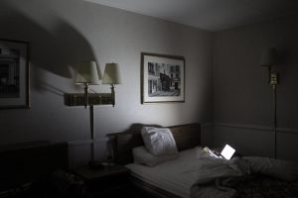“We have reservations at Gabriel’s tonight,” she said, toweling her hair. “James?” His laptop was open on the bed, but he must have left the room, probably to check with the concierge. She removed her black dress from the hanger and examined it, but her eyes wandered past the formal attire. Something in the picture on the wall had changed. A man in a suit now strolled along the sidewalk, smiling as if he hadn’t in so long. His expression was bright, like a man released from prison, and he waved to someone on the other side of the picture.

[The Uncle](http://www.100wordstory.org/the-uncle/)

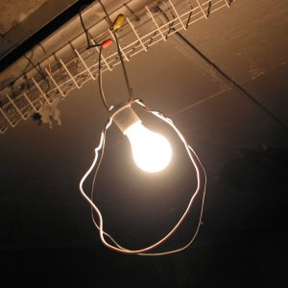I used to love to linger and breathe in the scent of our cluttered garage, and of Dad’s old pickup always parked there. Traces of carbon monoxide mingled with the must of old things for an aroma so seductive it was the suicide of choice for folks hell-bent on finding an easy way out. The coroner said too much booze made Dad pass out before he cut the motor that night, but I never believed it. Later on, the smell I came to hate most was his cologne-drenched brother who often came to hang out and play pinochle with Mom.

# [Photo Story: The Little Ones](http://www.100wordstory.org/photo-story-the-little-ones/)

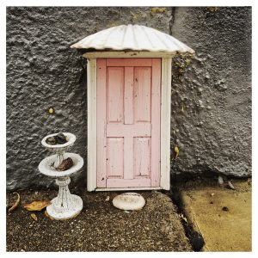They burrow between the cracks in our reality, craving the taste of clouds, feeling only the coarse, rough dirt below. Peering eyes examine but do not see, too small to notice. Living beneath us, they hear our speech, see our actions, smell our food. Our footsteps rattle their homes and shake their souls, they tremble in fear.

Their brains are small, perception of time flows by. See our trees fall, our towers rise, our people perish in the blink of an eye. They shake their heads in shame.

“If only they were small like us, they would see it all.”

[Building the Butternut](http://www.100wordstory.org/building-the-butternut/)

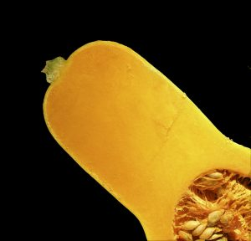It didn’t seem right, but we set the clocks and got the children up at midnight to go out and yell at the squash. A time-tested deterrent, it didn’t harm the vegetables, but the negative voice lodged in the prickly vine, alarming the squirrels like the sentry crows, who swooped down in a rage to chase them away. When we ran out of children we tried pre-recorded messages, but the squirrels severed the connection and dragged off the squash. Now, we summon our inner children, and the squash grows large. But we have to be quiet because of the neighbors.

# [“Exchange”](http://www.100wordstory.org/exchange/)

In 1969, I became an exchange student. I left home to spend the summer with my girlfriend’s family. They lived on a cliff, in a stucco house, overlooking Lake Ontario. The box radio sitting on top of the fridge played British Invasion, day in, day out. My girl used to test my language skills by pointing at the radio’s name-brand. Say this, she’d say, and I’d look at the script and spit out: Moe-Toe-Role-Ah. She’d laugh at my accent, which made me feel tiny, even though I’m terribly tall. I just needed more practice, that’s all—just like French kissing.

[Temporary Kin](http://www.100wordstory.org/temporary-kin/)

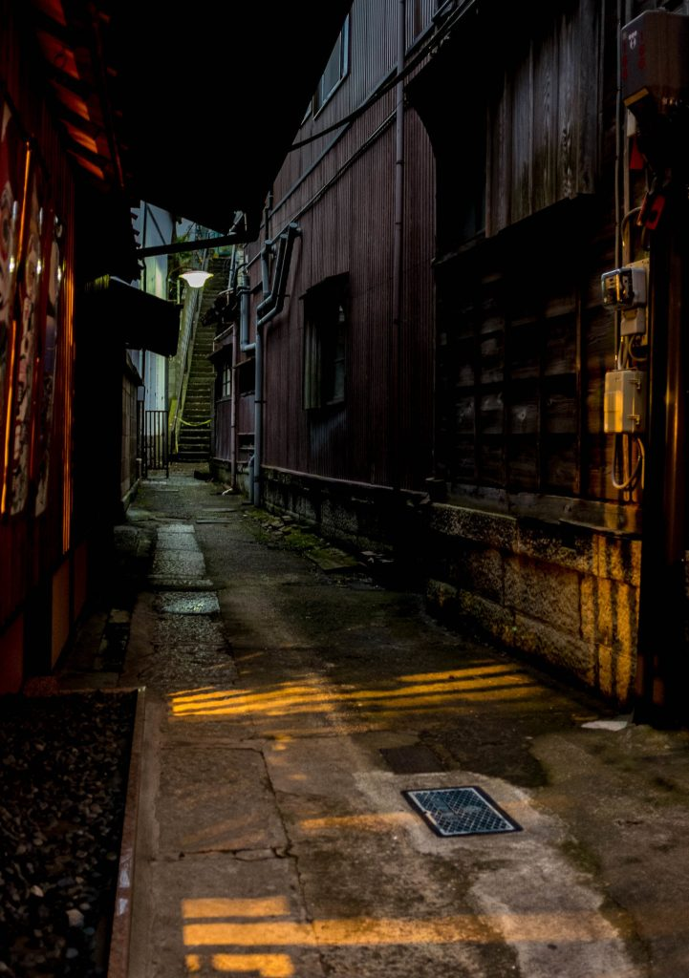We soon realized we were both 15, but Freddy looked much older. He was taller, broader, even had the beginning of a mustache. My face hadn’t even thought of such a thing. We’d met in that alley behind the big bookstore.

It wasn’t long before we were sharing my sleeping bag. His was so thin it was worthless, and winter was coming. After the first night, though, we knew we’d always want to, to hold each other, and more, until we fell asleep.

When they picked us up, we said we were brothers and begged them not to separate us.

# [Photo Story: A&V](http://www.100wordstory.org/photo-story-av/)

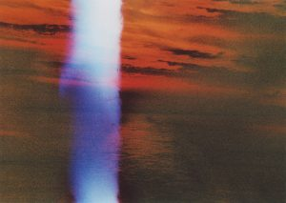We had a little photo store in Old Tappan. Our father named it Gold Star Photos. My brother and I spent summers in the back, where the studio was, not doing summer homework. ‘Click-flash’ went our Kodak disposables. Oh-so-temptingly near, the rolled-up backdrop for passport photos hung suspended from the ceiling like enormous toilet paper. Once, we took the end and pulled. The unrolling was glorious. Giant’s bumwad. Ha-ha-ha! A riot. You should have seen how we cried when scolded.

Still, shame didn’t stop us from peeking into the darkroom later, before the door slammed in our faces. Too late.

# [Things You Can Take](http://www.100wordstory.org/things-you-can-take/)

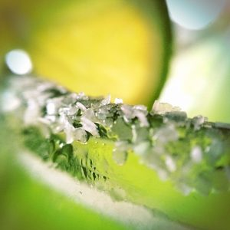A name. A message. Nobody’s shit. A hike. A hit. A beating.

Notes. A page from their book. Criticism.

A walk on the wild side. Ice with your drink. Salt with your margarita. A sip. Directions. Risks. A joy ride. The red pill. The car into the shop.

What you can get. The money and run. The long way home. The trash out.

A seat. Time off. An oath. Turns. The rap for it. It all in.

A break. Everything for granted. A moment to think about it. A different route. It all back. A life. Your life. A joke.

# [Hunger Pangs](http://www.100wordstory.org/hunger-pangs/)

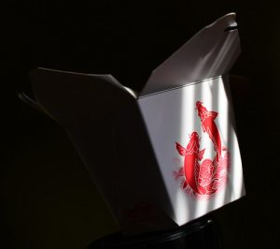We are sitting in the kitchen when I ask her if she still loves me.

As she answers, she begins to remove all of the things I don’t like from a paper container of fried rice—the peas, the carrots, the chicken—until there is nothing left but browned rice and slimy onions.

I feel her doing the same thing with her words—spoon feeding me answers of little substance because she thinks I like the taste of them, how easily they slip down to my stomach.

She’s right. I eat it all.

I’m still hungry late into the night.

# [Centum](http://www.100wordstory.org/centum/)

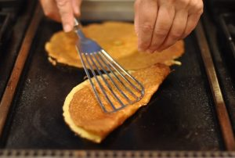Her kitchen appears unused. No plantain peels huddled in the corner. No orphan mustard seeds—until she wanders in between medication to make adai for her American grandson. He makes her laugh with his terrible Tamil. She strokes his face. Too young for beard, too old for advice, but she tells him what she told her children when they carried their oversized bags to the exam hall while she stood outside under the Neem tree.  
Just get me centum in math.

He smiles at the familiar centum. She smiles, gums and eyes. Cancer or not, she wants her 100.

# [Oh, For a Bee’s Experience of Clovers, and of Noon!](http://www.100wordstory.org/oh-for-a-bees-experience-of-clovers-and-of-noon/)

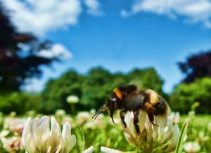The bee boards the crowded bus. Pulls out her worn copy of Emily Dickinson, plunges into its nectar.

She prefers her version of her favorite poem. In tiny careful writing, she changed all the he’s to she’s.

Her Feet are shod with Gauze –  
Her Helmet, is of gold…

Closing her eyes, she inhales it like incense. For a moment, she forgets the huge steel and glass hive waiting to receive her. The 10-hour shift of thorax-wracking toil, making honey-colored clothing for the rich. The bleary journey home. The sting of arriving too late to put her striped-pajama-wearing brood to bed.

[Aweful](http://www.100wordstory.org/aweful/)

s body draped on a diagonal across the bed. She could fit only when she curled herself into a ball. They hadn’t talked much since his trip to New York. His early bedtimes made her wonder what happened there. Her fingers wandered across laptop keys. Browser history. Craigslist. M4MW…Take me in?…My girl is home in Cali; I have permission. A photo of him, full mast. A photo of her, spine arched. Permission, a rage acidic in her esophagus. Corrosion she knew she’d never speak about. Corrosion made more poisonous because she’d stay.

# [Asparagus Pee](http://www.100wordstory.org/asparagus-pee/)

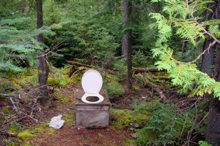Two days into the grim, doomed camping trip, Regina called off their wedding. They’d eaten shrooms, and she had the following revelation: the common ground they cherished in each another—concern about climate change, veganism, progressive politics, preference for a scruffy, wing-it form of travel, a high proportion of queer friends—was as arbitrary and happenstance as sharing the gene that made one’s urine smell funny after one ate asparagus. “It’s all irrelevant,” Regina said, tears icicling her cheeks. Ted knew he needed to reel her back, but all he could do was stare, entranced at the frothy, hat-shaped clouds.

[In Every Girl There Is a Forest](http://www.100wordstory.org/in-every-girl-there-is-a-forest/)

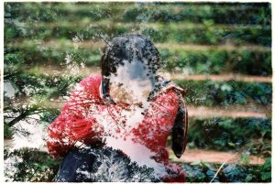In every forest there is a cabin. In every cabin there is a stove. In every stove there is an ash pile. In every ash pile there is a bone. In every bone there is a story. In every story there is a yearning. In every yearning there is a prize. In every prize there is a cost. In every cost there is a cut. In every cut there is a ghost. In every ghost there is a home. In every home there is a witch. In every witch there is a girl. In every girl there is a forest.

# [A Gray Inchworm on a Gray Sidewalk](http://www.100wordstory.org/a-gray-inchworm-on-a-gray-sidewalk/)

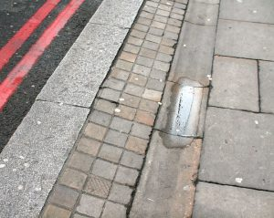How easily the runner could have crushed it. The inchworm’s camouflage, which conceals it from predators, makes the inchworm vulnerable to the human jogging along neighborhood sidewalks, the human who does not intend the inchworm harm. Pounding the pavement and enduring the earth’s return punches is the human’s attempt to postpone death. If the runner hadn’t seen the inchworm, if the inchworm had gotten caught between these punches, the runner probably wouldn’t have felt anything more than the usual heaviness and the usual fight to keep going. But the runner did see the inchworm. She felt lightness as she leapt.

[In This Drought](http://www.100wordstory.org/in-this-drought/)

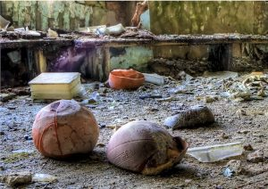Before, we blamed things on the rain: canceled parades, flooding and mudslides, flattened hair, postponed races, baseball games, our happiness. Now, in this drought, we stand in front of our windows watching the desiccated ground crack and lurch, praying  
that the air conditioning unit will operate for another day.

We miss the rat-tat-tat of sprinklers, the pulsating drone lawn mowers, the whirring bicycle wheels, and the heartbeat thump of basketballs dashed across driveways turning slowly to concrete dust.

Our limbs are listless, as the air, largely invisible before, surrounds us, an  
invading army.

Fighting never looked so much like defeat.

# [Snowbird](http://www.100wordstory.org/snowbird/)

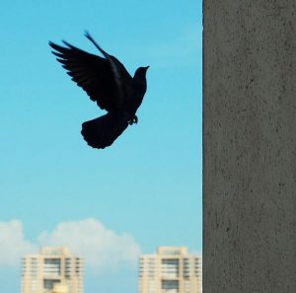Doris’ balcony bends toward the sea. She is in a high rise looking down at birds. Gulls scream and fly north to the next resort. All that’s left now are pigeons on the patio. They scavenge through the purpling decorative cabbage. She hasn’t seen a pelican yet, just the same birds she came here to get away from. They look like feathered cataracts in a kale eyeball. She sees a buried Titan with umbrellas for pectorals. He struggles to emerge from beneath the sodden November sand, beaten down by so many tenacious dog walkers. He has his eye on her.

# [Photo Story: Two Masterpieces about Jello](http://www.100wordstory.org/photo-story-two-masterpieces-about-jello/)

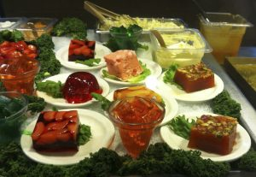Everyone makes yum-yum noises as they dole servings onto their plates. Hilda preens. Go on, eat, darlings. But, is that a hair in the perfection salad? That black coiled thing. The party pretends not to notice. I’ve forgotten the cream, she says, hefting it back into the kitchen. She takes a fork and incises a sliver, interloper inside. It splits forgivingly. There, unmistakably hair. Lenore turns the corner, frowning. “Darling, we’re missing the hostess.” She laughs as Hilda puts down the fork sheepishly. “Naughty, were you sneaking bites?” Hilda smiles, gelatin and the hair rolling in her mouth, and swallows.

# [Aunt](http://www.100wordstory.org/aunt/)

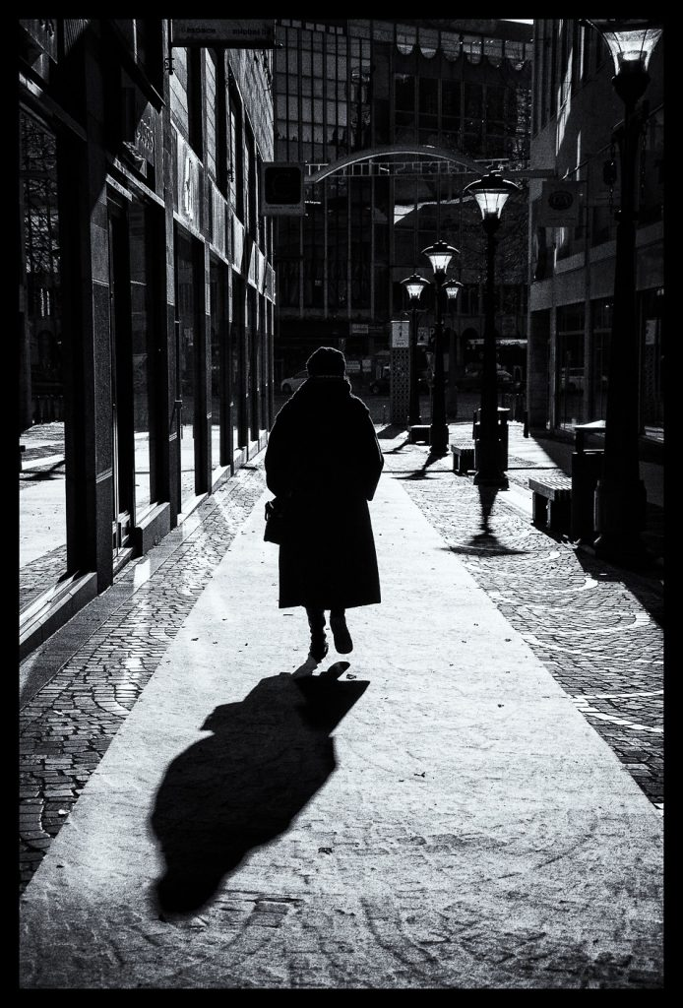The 30-year-old recording carries little of my father’s sister, no more than she was in life, ever-present shadow of her mother, suppressed laughter, coy glances, hair pulled back, glow-less skin, feet trapped in grey or beige orthopedic boots, old fashioned skirts, never an act of defiance, of protestation, never the shred of an opinion. She only knew how to echo her mother’s precise speech, her own language mere leftovers of that Mother. Yet, in this recording, the thump thump of her footsteps, the clunky rhythm of her crippled walk, discordant music, thump thump, arresting, uniquely hers, breaks through, clamors for attention.

# [Drive](http://www.100wordstory.org/drive/)

After the diagnosis, Aunt Jessie quit teaching and bought a racecar, oxy-white, a real hot ride. I sat shotgun down to Miami so Jessie could street-race for pink slips. You need a second in that scene, a hostage: keeps you honest with your wager. I sat on the curb with the other gal’s kid. The big man laid a gun against my skull and stared Jessie down through her windshield. The trigger pulled with a noise like Jesus come, but it was only the starting pistol; Jessie flew off down the road—engine roar, dust cloud, each moment losing ground.

# [Hindsight](http://www.100wordstory.org/hindsight/)

Trouble came because we didn’t waterproof the birdhouse. The paint held up, at first: a child’s pastel palette that drew sparrows and made the tree look festive. Harsh winters stripped the pinks and peeled the blues to graying wood. That’s when the yellow jackets nested. We drowned them. Tossed the house into the backwoods to decay. Now, instead of songbirds, we have spiked-toothed, bat-winged imps. They breed like mad inside the ruined house. Already, they’ve devoured our hens, the barn cats, and beehives. Still, we hear their stomachs growl. We hide behind our weathered walls, holding cleavers to the cracks.